**Group 27**

**IS 436 Section 02**

**Structured Systems Analysis and Design**

**Deliverable 4**

**11/21/2017**

Bryan Baek

Brendan Bessel

Kalabe Mulugeta

Josiah Tillett

Xinbo Yang

**Table of Contents**

1. Table of Contents…………………………………………...………….………………….1
2. Entity Relation Diagram (ERD)..…………….………….……….….…………………….2
3. Explanation of entities and relationships.…………………………………….…..……….3
4. Syntax issues throughout/matching with DFD and use cases…..………………………....5
5. Alternative Matrix three alternatives and descriptions..…………………………………..6
6. Matrix per group member...…….………………………………………..………………..8
7. Team Matrix..…………….………….………………………..….….………..………….13
8. Explanation of Team Choice..…………….………….……….….….……..…………….14
9. Architecture Matrix..…………….………….………………...….….………………..….15
10. Explanation of Architecture Matrix..…………….…………...……….….…………..….15
11. HW/SW specs based on architecture chosen..…………….………….……….….…...…16

**Entity Relation Diagram (ERD)**

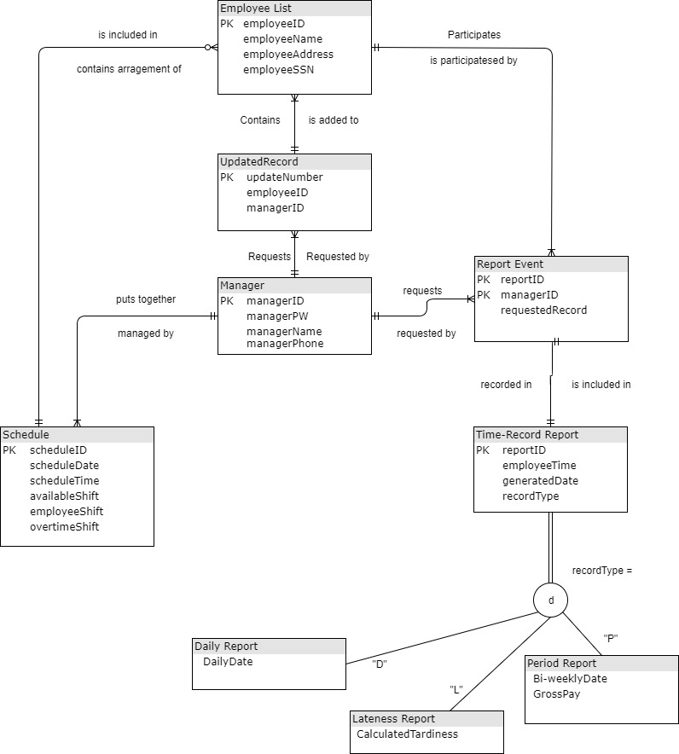

**Explanation of entities and relationships**

1. **Entity**: Employee List

**Description**: The List of employees of the company

**Attributes**:

* employeeID: *Primary Key* The unique ID number for every employee of Aviation Port Services.
* employeeName: Name of the employee
* employeeAddress: Home address of every employee
* employeeSSN: Social Security Number for every employee

**Relationships**:

* **One to Many with Report Event:** One employee participates in many event reports.
* **One to One with Schedule:** One employee is included in one schedule
* **One to Many with Updated Record:** One employee is added to many updated records

1. **Entity**: Schedule

**Description**: The schedule for all employees at Aviation Port Services

**Attributes**:

* scheduleID: *Primary Key*. unique ID number for every schedule within the system
* scheduleDate: The schedule for a particular date within the system
* scheduleTime: The hours that are scheduled to be worked within the system
* availableShift: List of any available shifts that have yet to be picked up
* employeeShift: List of employee shifts
* overtimeShift: List of employee shifts that are categorized as overtime

**Relationships**:

* **One to Many with Employee List**: One schedule can include many employees in it.
* **One to One with Manager**: One schedule can be put together by one manager.

1. **Entity**: Manager

**Description**: The database for all of the managers of Aviation Port Services

**Attributes**:

* managerID: *Primary Key*. The unique ID for every manager within the system
* managerPW:
* managerName: The name of every manager within the system
* managerPhone: The phone number of every manager within the system

**Relationships**:

* **One to Many with Schedule**: One manager can manage many schedules.
* **One to Many with Updated Record**: One manager can request many records
* **One to Many with Report Event**: One manager can request multiple report events.

1. **Entity**: Time-Record Report

**Description**: The report generation area of the system that logs timekeeping, tardiness as well as overtime hours and pay.

**Attributes**:

* reportID: Primary Key: The unique ID for every report that is generated
* employeeTime: The hours that each employee has clocked in
* generatedDate: The date that is generated within the system
* recordType: The type of record that is being stored in the system

**Subentities**:

* Daily Report
  + Attributes:
    - DailyDate
* Lateness Report
  + Attributes:
    - Calculated Tardiness
* Period Report
  + Attributes:
    - Bi-weekly Date
    - Gross Pay

Relationships:

* One to One with Report Event: There is only one time record report recorded for every report event.

1. **Associative Entity**: Report Event

**Description**: Stores the manager and report values in order to help create the weekly and bi- weekly reports.

**Attributes**:

* reportID: *Primary Key*: The unique ID for every report generated.
* managerID: *Primary Key*: the unique ID given to every manager
* requestedRecord: log of all records that are to be requested.

**Relationships**:

* **One to One with Time Record Report**: Only one report event is included in every time record report
* **One to Many with Employee List**: One employee participates with one many reports.

**Syntax issues matching with DFD and use cases**

**Overall set**

1. Relation words between two entity may better has arrow on it, So it can reduce the misunderstanding, for example: Employee list is included in schedule or Schedule is included in employee list will be confusing if viewer does not understand the design at first time.
2. For Entity where contain other PK of another Entity, such as Updated Record contain both Manager ID and Employee ID, It may need be mark out as foreign Key.
3. since the employee record is managed by manager and used By record and payroll generate, it may need some relation

**Employee list**

1. name should be Employee, since one record for one Employee will be individual Entity, and whole list is more like the data store.

**Updated Record**

1. PK update Number may cause some confusing, Update ID may Easier understand.
2. I do wonder if this entity should be accessed by other report, Since data inside would be used during report generating process, So it may need some link to report event or may be include in employee Entity.

**Manager**

1. No specific change need

**Schedule**

1. All shift type may merge to shift query since there are no specific In DFD

**Report Event**

1. Has same Record ID PK like Time-Record Event, It may need to be renamed, or mark as foreigner key. Since entity may better not share the primal key.
2. Manager Key may need be foreigner key
3. Requested record may need link with updated record

**Time-Record Event**

1. Has same PK Record ID like Report Event, May need change if they are not share same Primal key.

**Alternative Matrix three alternatives and descriptions**

**Alternative 1: Contracted Custom Application Using Linux, Apache, MySQL, PHP**

This alternative utilizes an external programmer to build a custom designed solution for our system. The price is unclear because of the time needed to complete the project.

**Pros**

* Custom made to fit specific needs of company
* Provides customizable interface
* Integrates well with existing system due to starting over from scratch
* Potentially set amount for payment, no monthly fees after implementation

**Cons**

* Software specific only to Port Aviation Services
* Longer time needed to develop and test product
* Higher learning curve for employees
* Lack the extra functionality of a prepackaged system

**Alternative 2 - Packaged Software: Tsheets**

This alternative is a packaged, licensed software. There are different editions available but for the needs of our company the basic package should be enough.

**Pros**

* Able to support multiple OSes including Android, iOS and Mac OS
* Works with other software including Quickbooks, Square, Gusto
* Potentially less expensive and time consuming than a custom made solution
* Mobile app allows users to check in as soon as they are on the premise
* Lower learning curve
* Customer support
* Used by other companies
* Cloud based
* No need to purchase special hardware

**Cons**

* Less customizable interface then building from scratch
* GPS tracking has potential to be abused
* Reliant on someone else’s cloud
* Customer service could be slow to respond due to other customers
* Monthly upkeep payments
* Relies on employees having smartphones

**Alternative 3 - Packaged Software: Clock Shark**

This alternative is a packaged, licensed software. There are different editions available but for the needs of our company the basic package should be enough. This is more or less the same as the previous packaged software option but with more features and a higher price point.

**Pros**

* Cloud based
* Multi platform (Android, iOS, Windows Mobile, Windows, Mac)
* Long distance GPS tracking
* No need to purchase special hardware
* Built in schedule creation
* Real-time reports
* Supervisor can still clock in for employees without smartphones
* Notifies manager when employees leave jobsite while still clocked in
* Widely tested across multiple industries
* Quick implementation
* Low learning curve

**Cons**

* Similar to the cons of the previous prepackaged software
* Cloud based but using someone else’s cloud
* Reliant on external customer service should something go down
* Minimally customizable interface
* Designed for long distance industries such as construction, GPS tracking feature may not be granular enough to work within a building
* Extra features drive up the price
* Monthly upkeep payments

**Matrix per group member**

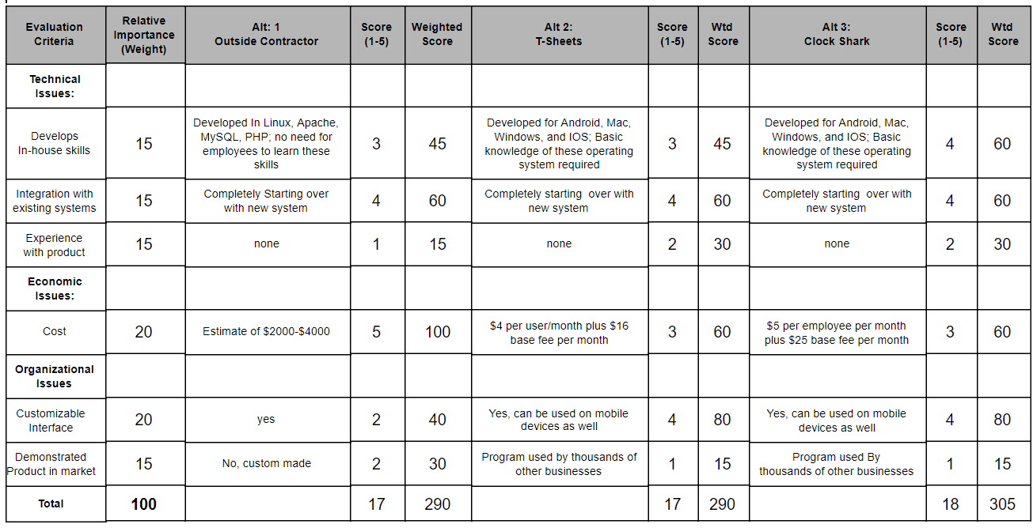

Bryan Baek

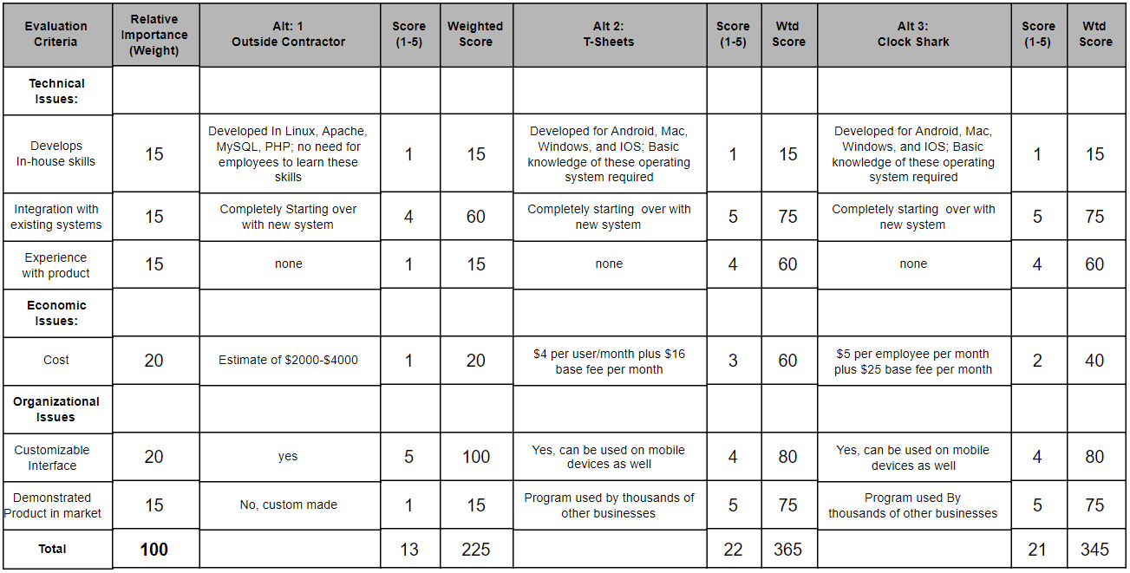

Brendan Bessel

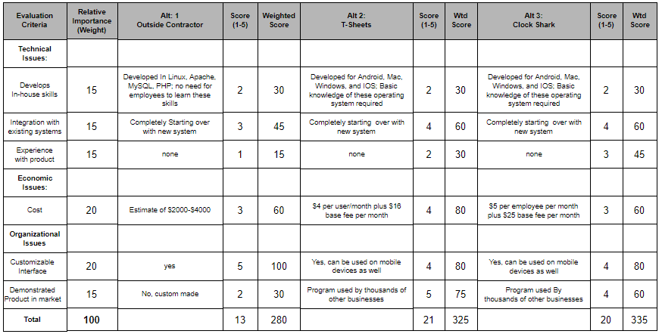

Kalabe Mulugeta

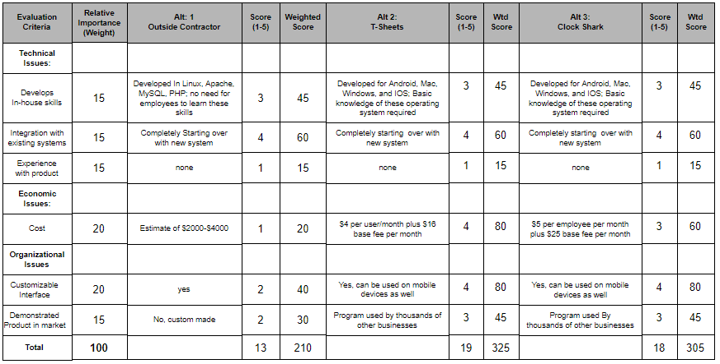

Josiah Tillett

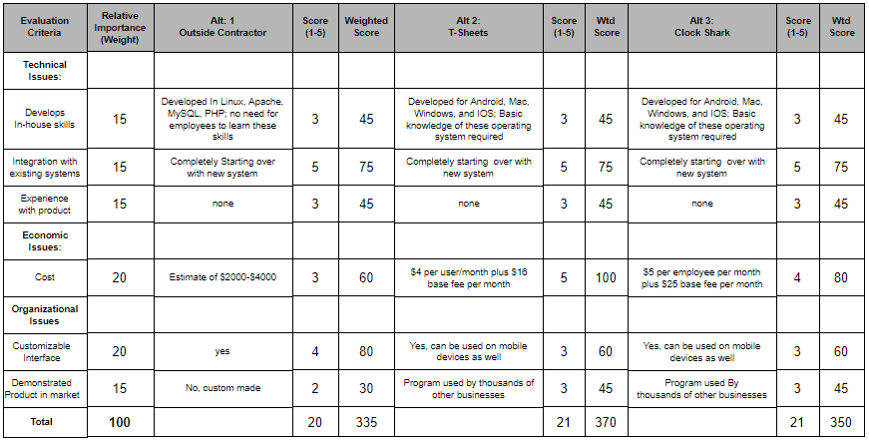

Xinbo Yang

**Team Matrix**

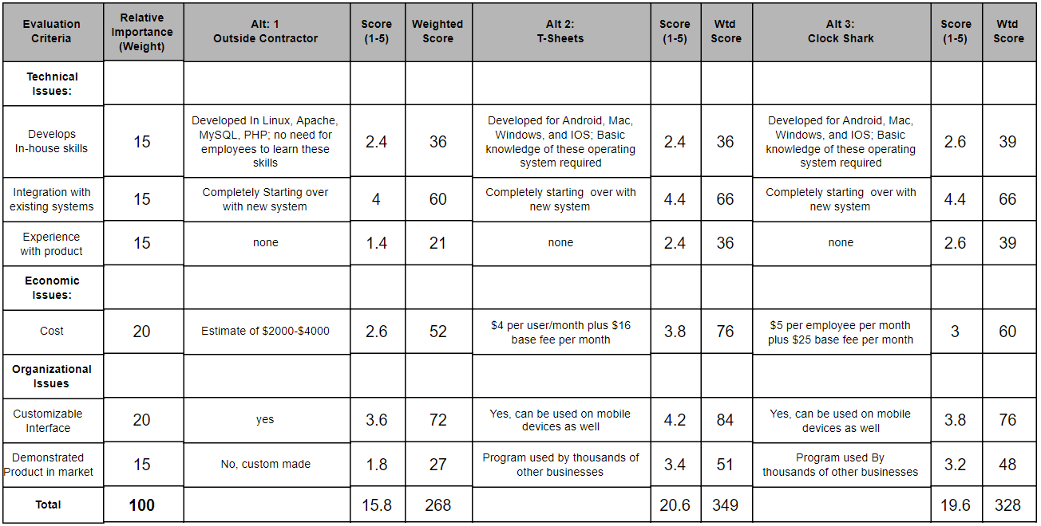

**Explanation of Team Choice**

Our team choice is based on the final average alternative matrix score.

Since we choose from 2 package product or outside contractor,

There are not much difference on in-house skill build when the contractor build

System also require no more in house skill to implement or use, but some

Of us consider the Clock Shark may help understand the properties of same kind

System, they rate it a little higher.

Because we started on brand new system, those package

Product will has slightly advantage over contractor product, since they are mature system

That already run for years.

Even though we do not has much experience about any of them

(especially the contractor product, since it will be built from scratch), some member is more

familiar with clock shark, so it has little advantage.

The cost is major factor we looking at. Since the estimate of contractor product is not include

any maintain cost, future update cost, potential integration risk, the package product will be

more economic effective for long term performance. T-Sheets only has 80% of user fee and

around 85% of base fee compare with clock shark, it has much higher score in this section.

The customize interface is another major factor we looking for, since the T-Sheets already has

Flexible customize interface and integrate well with mobile OS, it eventually better than other.

There is no similar example can be found on contractor product, so package product provide better

Demonstration, some of us feel better about the trial and overview of T-Sheet, so it has higher score.

Due to its economic price on long term and well-designed flexible interface, we choose T-sheets

From three alternative.

**Architecture Matrix**

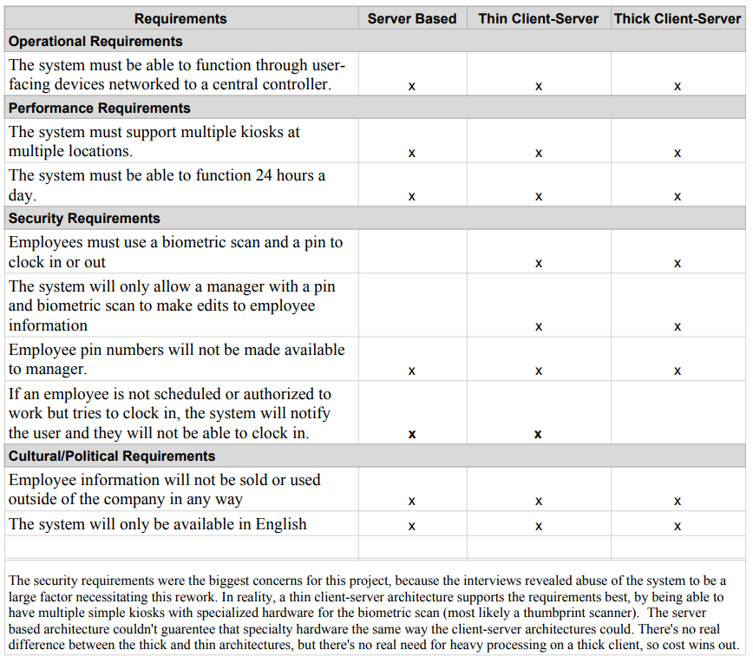

**Explanation of Architecture Matrix**

The security requirements were the biggest concerns for this project, because the interviews revealed abuse of the system to be a large factor necessitating this rework. In reality, a thin client-server architecture supports the requirements best, by being able to have multiple simple kiosks with specialized hardware for the biometric scan (most likely a thumbprint scanner). The server based architecture couldn't guarantee that specialty hardware the same way the client-server architectures could. There's no real difference between the thick and thin architectures, but there's no real need for heavy processing on a thick client, so cost wins out.

**HW/SW specs based on architecture chosen**

Hardware：

* Cloud server if build by contractor
* Integrate with existing biometric scan if software does not have addition identity check function other than ID.
* General table top and lap top computer on current market(PC or MAC), also general smartphone on current market(such as iPhone, or android) if function require mobile platform support.

Software：

* Multi platform (Windows, Mac, may also require Android, iOS, Windows Mobile if function need working with mobile platform)
* Cloud based (so it can be access from large geometric area)
* Multi Browser support if web based, such as google chrome, firefox, safari.
* Further identity check function other than ID (can be either biometric or geometric).